STRUCTURE AND DYNAMIC MEMORY MANAGEMENT

- Refer the question 1 solved in “Structure and function”. Extend the above program to read a number of records from the user as a single command line argument (each record is delimited by a semicolon and record fields are delimited by comma) and store in an array of structures.
Sample input and output are given below.
Input: “user1,90;user21,100, userABC,56,userX,40”;
Output:
No. of records: 4
Record 1:
Name:user1, Percentage:90
Record 2:
Name:user21, Percentage:100
Record 3:
Name:userABC, Percentage:56
Record 4:
Name:userX, Percentage:40

Implement all required functions and call them to get the desired output.
Check for memory leak.
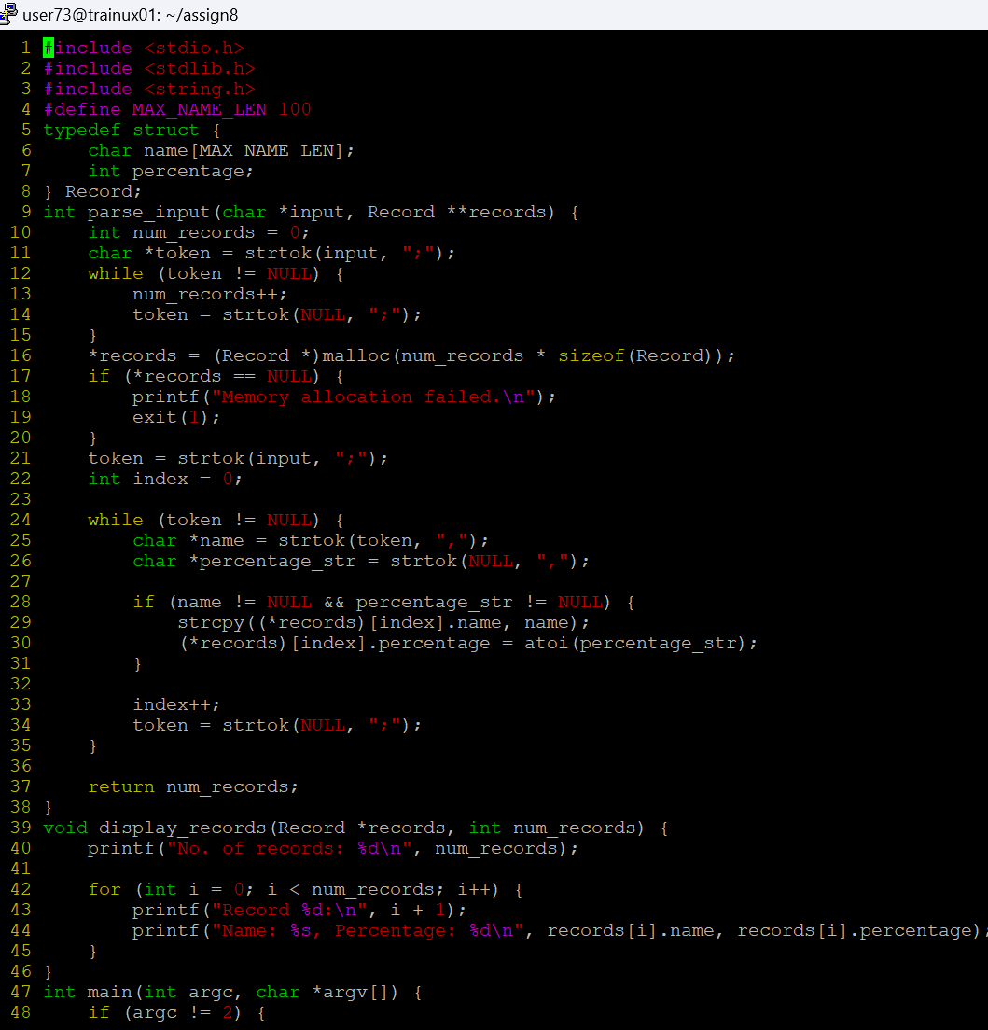

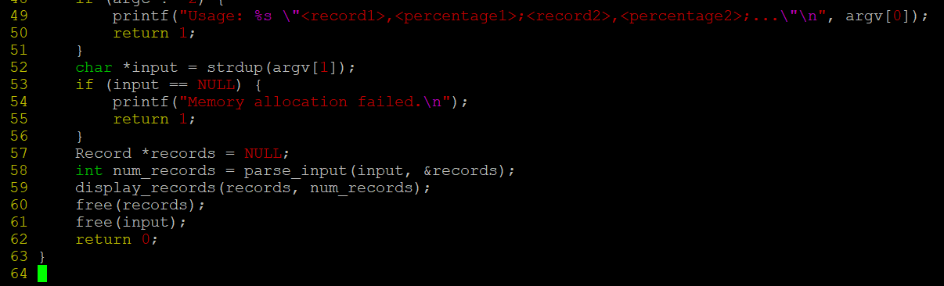
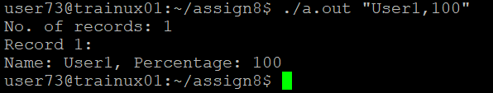

Attempt any one of the following questions:

2a. Extend Q1. Above and add 3 functions below.
//to search for a name and to replace it with a user defined name, return replaced string
char*search_update(char *searchstr, char *replacestr);

//search and delete the record with given name or percentage value, return SUCCESS on successful delete else FAILURE
int delete_record(char *searchstr, int percent);

//search for name and if found create a copy of the record in newstudent
and return SUCCESS, else FAILURE

int copy(char *name, struct student **newstudent);
